**T.Y BTech (ECM) – Image Processing**

**Tutorial No -2 : Types of Image and Image Resolution**

* **Problem Statement** –

1. Write a program to convert RGB image into grayscale and binary images using MATLAB.
2. Write a program to demonstrate the ability to find an optimal resolution for the image, balancing the trade-off between image quality and file size."

* **Objective:** To analyze the effect of changing the resolution on image quality and file size.
* **Tools Required:** MATLAB
* **Theory:** Digital images play an important role both in daily life applications as well as in the areas of research technology. The digital image processing refers to the manipulation of an image by means of processor. The different elements of an image processing system include image acquisition, image storage, image processing and display
* **Specify the syntax used in MATLAB for following operation**.

1. **rgb2gray**
2. **imbinarize**
3. **numel**
4. mage crop
5. Image information
6. Image write
7. Displaying detailed information about pixel values

* **Conclusion**:
* **Discussion** –

***Program 1 :*** Write a program to convert RGB image into grayscale and binary images using MATLAB.

clear all;

% Read in the color image

RGB = imread('flower.png');

figure(1) , imshow(RGB);

% convert color in the grayscale image

A=rgb2gray(RGB);

figure(2), imshow(A);

% convert color in the binary image

D=imadjust(RGB,[0 1],[1 0]);

figure(3), imshow(D);

C=im2bw(A);

figure(4), imshow(C);

***Results:***

***Output***

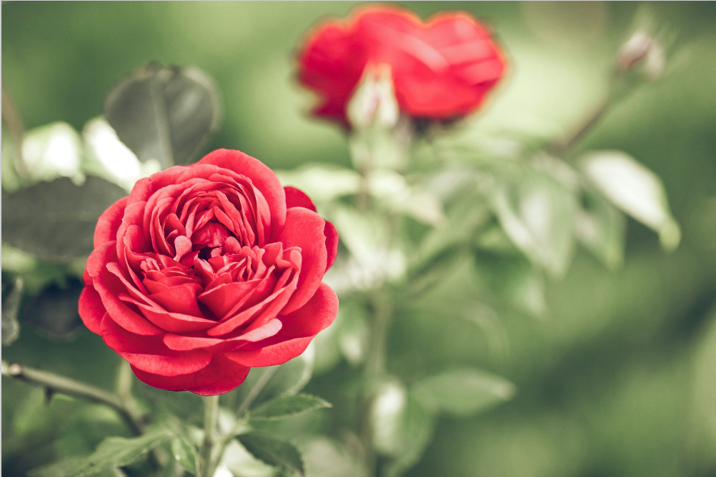   

***Program2:*** *To demonstrate the ability to find an optimal resolution for the image, balancing the trade-off between image quality and file size."*

% Read color image

RGB = imread('peppers.png');

figure(1) , imshow(RGB);

title('Original Image');

imresize(RGB,2);

f1=imresize(imresize(RGB,1/2),2);

figure(2) , imshow(f1)

title('128X128 Resolution ');

f2=imresize(imresize(RGB,1/4),4);

figure(3) , imshow(f2)

title('64X64 Resolution ');

f3=imresize(imresize(RGB,1/8),8);

figure(4) , imshow(f3)

title('32X32 Resolution ');

f4=imresize(imresize(RGB,1/16),16);

figure(5) , imshow(f4)

title('16X16 Resolution ');

f5=imresize(imresize(RGB,1/32),32);

figure(6) , imshow(f5)

title('8X8 Resolution ');

***Results:***

***Output***

